**Project Development phase**

**Project Development delivery of sprint 4**

|  |  |
| --- | --- |
| Team ID | PNT2022TMID50833 |
| Project name | Smart Crop Protection system for agriculture |

**Architecture:** 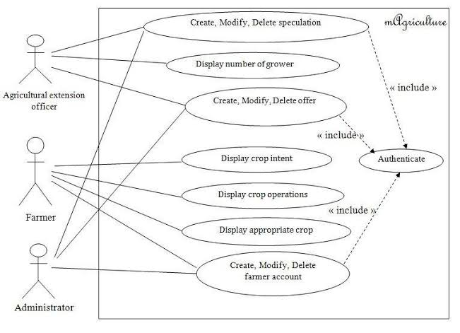

**Application features:**

* diversity in crops.
* difference in climate supports crops.
* large land for crops.
* Protection of crops against pests means reducing pests and creating the most adverse conditions for their adaptation.
* Although some insects do not pose an economic threat to production, they can be disease vectors.
* Farmers should therefore protect crops from pests even if there is no immediate threat of culture damage